

A Project Synopsis

On

“LANE FOLLOWING MOBILE ROBOT”

Submitted in partial fulfillment of the requirement of

University of Mumbai for the Degree of

**Bachelor of Engineering**

In

**Electronics Engineering Department**

Submitted By

**CHINMAY BHOIR**

**MAHENDRA GUDLA**

**SUCHITA BOGA**

**SANDHYA YADAV**

Under the Guidance of

**PROF. VIJAYKUMAR CHAUDHARI**

**Electronics Engineering Department**

**TERNA ENGINEERING COLLEGE NERUL**

**UNIVERSITY OF MUMBAI**

**Academic Year 2021 – 22**

|  |  |  |
| --- | --- | --- |
|  |  |  |
|  |  |  |
|  |  |  |

|  |  |
| --- | --- |
|  |  |

CERTIFICATE

This is to certify that the requirements for the synopsis entitled ‘**LANE FOLLOWING MOBILE ROBOT**’ have been successfully completed by the following students:

**Name Enrollment No.**

Chinmay Bhoir TU1F1819006

Mahendra Gudla TU1F1819009

Suchita Boga TU1S1920004

Sandhya Yadav TU1S1920008

in partial fulfillment of Bachelor of Engineering of Mumbai University in the Department of Electronics Engineering, Terna Engineering College Nerul during the Academic Year 2021 – 2022.

**_____________________**

**Project Guide**

**(Prof. Vijaykumar Chaudhari)**

**_____________________ ___________________**

**Internal Examiner Project Coordinator Mrs. R.V.Chimankare**

**______________________ _____________________**

**Head of Department Principal**

**Dr. B.G.Hogade Dr. L. K. Ragha**

**TABLE OF CONTENT**

Abstract *5*

1. **Introduction**

1.1 Background………………………………………………………… *6*

1.2 Motivation………………………………………………………….. *6*

1. **Problem Definition**

2.1Problem Statement………………………………………………….. *7*

1. **Literature Survey**

3.1 Literature Survey Summary………………………………………... *8*

1. **Proposed System**

4.1 Overview…………………………………………………………… *9*

1. **Methodology**
   1. System Design……………………………………………………... *10*
   2. System Component Selection……………………………………… *10*
   3. Implementation…………………………………………………….. *12*
2. **Applications *13***
3. **Conclusion *14***

**Summary *14***

**Literature Cited**  ***15***

**Acknowledgement *16***

**List of Figures**

|  |  |  |
| --- | --- | --- |
| Figure 5.1 | System Design | *10* |
|  |  |  |

**List of Tables**

|  |  |  |
| --- | --- | --- |
| Table 3 | Literature Survey | *8* |
|  |  |  |

**ABSTRACT**

***Lane Following is one of the most important aspects of robotics. A Lane Following Mobile Robot is an autonomous robot which is able to follow a lane that is drawn on the surface consisting of a contrasting color. It is designed to move automatically and follow the lane. The robot uses Raspberry Pi Camera to identify the lane and thus assisting the robot to stay on the track. The robot is driven by DC gear motors to control the movement of the wheels. The Arduino Uno interface is used to perform and implement algorithms to control the speed of the motors and to control steering of the robot to travel along the lane. This project aims to implement the algorithm and control the movement of the robot by proper control parameters and thus achieving better performance. We will be applying a learned perspective transformation in addition to the fixed “birds-eye view” transformation. This ensures robust lane fitting even if the road plane changes. It can be used industrial automated equipment carriers, small household applications, tour guides in museums.***

***Keywords: Raspberry Pi, Arduino Uno, Image Processing.***

# 1. Introduction

This project Lane Following Mobile Robot uses camera sensors and modules to determine the lane and follow the path. Lane following robot is a machine that can follow a path. The path can be visible like a white line on a surface. Detecting the lane and maneuvering the robot to stay on course, while constantly correcting wrong moves forms a simple yet effective system. Camera- based lane detection is what is used to detect the lanes and position the robot in between the lanes properly and prevent the lane departure.

**1.1 Background**

In the industries, carriers are required to carry products from one point to another point which are usually in separate buildings or blocks. Conventionally, carts or trucks were used with human drivers. Unreliability and inefficiency in this part of the assembly line formed the weakest link. This project is to automate this sector, using carts to follow a lane instead of team of workers.

**1.2 Motivation**

How ants always travel in a line, following an invisible route in search of food, or back home. Ever thought about a robot which follows lane? The purpose of this project is to recreate in terms of machines what one see around to solve a problem or fulfill a requirement.

The area will be benefitted from the project:

* Industrial automated equipment carriers.
* Entertainment and small household applications.
* Tour guides in museums and other similar applications.

**2. The Problem Definition**

**2.1Problem Statement**

The task is to build an autonomous car that can basically control or change the course of direction without any human input. One of the use cases are in industries where certain goods are being placed in from one area to another and using this system we can properly reduce manpower and time delay.

In the industries, carriers are required to carry products from one point to another point which are usually in separate buildings or blocks. Conventionally, carts or trucks were used with human drivers. Unreliability and inefficiency in this part of the assembly line formed the weakest link. Our task is to build an autonomous car that can basically control or change the course of direction without any human input and using this system, we can properly reduce manpower and time delay.

**3. Literature Survey**

|  |  |  |
| --- | --- | --- |
| **SN** | **Paper** | **Advantages and Disadvantages** |
| 1. | Yeongcheol Cho  Published: **2017** | Advantages:   * It has reduced computation complexity. * Gaussian filter is applied for removing the noise in image data.   Limitations:   * Cost increases because there is the use of 2 sensors. |
| 2. | Jiyoung Jung ID and Sung-Ho Bae  Published: **2018** | Advantages:   * Using 3D Lidar point cloud, we categorized the points of the drivable region and distinguished the points of the road signs on the ground.   Limitations:   * Roads with drastic slopes and severe curvatures in mountainous areas could be challenging. |
| 3. | Jong-Ho Han and Hyun-Woo Kim  Published: **2021** | Advantages:   * Ensures safe driving under unfavorable road conditions such as fog.   Limitations:   * It is difficult to detect the road lines beneath the parked cars on the side. |

**4. Proposed System**

**4.1 Overview**

First the image is captured using raspberry pi camera. Every image that is being processed in in BGR format and for open cv to work, the image is then converted in RGB format. With this RGB format, region of interest is processed.

Using region of interest, a perspective view is determined. The frame is then converted to grayscale image for detecting the edges and processing the two lines in the lane. Finally using the center of width of frame, the car follows with respective to the center and lines of frame.

**5. Methodology**

**5.1 System Design**

The basic operation of lane follower are:

* Camera is mounted in the front of the robot to capture the lane image. This will detect the lane by finding lane marks.
* Raspberry pi is the master device of our system and Arduino is slave device. Arduino is used to perform and implement the control the speed of the motor and to control steering of the robot so that it can travel along the lane.

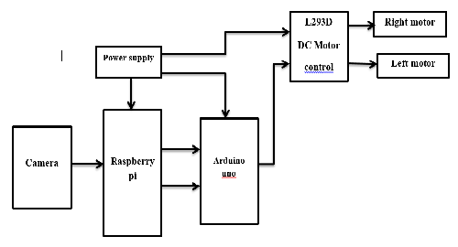

**5.2 System Component Selection**

**HARDWARE REQUIREMENTS:**

1. **Raspberry pi**: raspberry pi is small computer that easily connect to interface with lot os hardware and it is support multiple languages.

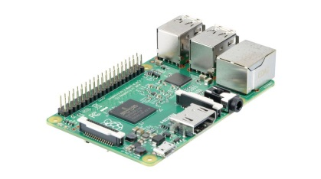

2. **Ardinuo UNO:** Our project is power intensive, then you need a slave device to reduce an overhead from your main controller. So that’s why we use Arduino UNO as slave device so that you can establish a communication link between main microcontroller and slave device. According to the image processing done using raspberry pi, the data is sent to Arduino and which would in turn control the motor driver to move in a particular direction. For eg: using left () method would be executed to turn the vehicle in left direction.

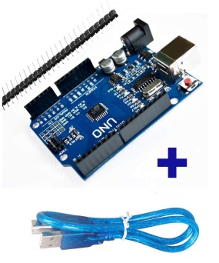

1. **DC Motors drive:** used for control the motor.

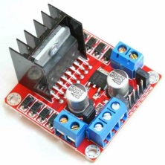 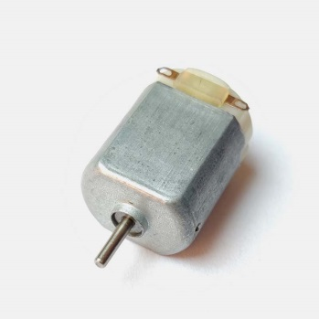

1. **Mono camera:** used for capturing images.

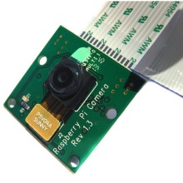

**SOFTWARES USED:** **C++.**

**5.3 Implementation**

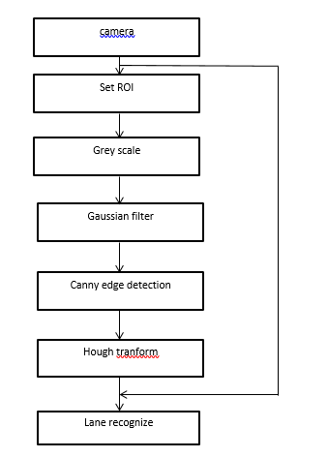

Lane recognize [1]

**6 Applications**

1. Industrial automated equipment carriers.
2. Entertainment and small household applications.
3. Tour guides in museums and other similar applications.

**7 Conclusion**

This paper proposed a very cost-efficient autonomous robot where we used Perspective Transformation and Canny Edge Detection Algorithms to detect lane. The position information was fed from the Raspberry Pi to Arduino, which controlled the motors speed and turns.

**SUMMARY**

The system is completed in to the three division i.e is the Input system, Processing System and Output system. Input system is camera. It captures the surrounding images, to determine lane and obstacles on the lane. Processing system is done by raspberry pi and Arduino Uno. Raspberry pi instructs Arduino Uno to control the moment of the robot. Arduino Uno interface consisting microcontroller Atmega328P which works on the basic of the logic of the program burn to it. Output system consist combination of L298 Motor Driver and DC gear-motors.

**LITERATURE CITED**

* + - 1. *A Lane Following Mobile Robot Navigation System Using Mono Camera*

*Author: Yeongcheol Cho*

*Published: 2017*

* + - 1. *Real-Time Road Lane Detection in Urban Areas Using LiDAR Data*

*Author: Jiyoung Jung ID and Sung-Ho Bae*

*Published: 2018*

* + - 1. *Lane Detection Algorithm Using LRF for Autonomous Navigation of Mobile Robot*

*Author: Jong-Ho Han and Hyun-Woo Kim*

*Published: 2021*

**ACKNOWLEDGEMENT**

It is our privilege to express our sincerest regards to our Principal Dr. L. K. Ragha for his support and encouragement.

We deeply express our sincere thanks to Head of Department Prof. Hogade, Project coordinator Prof. Renuka Chimankare for allowing us to present the project on the topic 'LANE FOLLOWING MOBILE ROBOT'.

It is our privilege to express our sincerest regards to our project guide Prof. Vijaykumar Chaudhari, whose encouragement, guidance and support from the initial to the final level enabled us to develop an understanding of the subject.

**REFERENCES**

*1. Autonomous Self-Driving Car using Raspberry Pi Model*

*Author: Mr. Nihal A Shetty*

*Published: 2019*

*2. Real-time Lane detection and Motion Planning in Raspberry Pi and Arduino for an Autonomous Vehicle Prototype*

*Author: Alfa Rossi*

*Published: 2020*